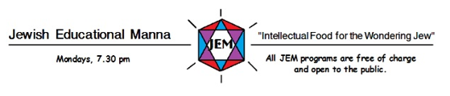

JEM Programs for 2023-2024
JEM will return in October of 2023 for its 19th season of edifying,
stimulating, and entertaining presentations.

The first JEM program for 2023-2024 will be held at the Jewish Community Centre on
Monday, October 16, at 7:30 p.m.
All the other JEM Programs will be held on Zoom.

TOPIC | DATE | SPEAKER
Getting Their Act Together: The Formation of an Asylum-Seeking Community in Israel | October 16, 2023 | Oded Oron
The Canadian Jewish Experience | October 23 | Allan Levine  Sponsor: Congregation Beth Tefilah
What's in a Name? On the Uses and Abuses of Jewish Names | October 30 | Kalman Weiser
Rescuers of Jews during the Nazi Era: Who were They and Why did They do it? | November 6 | Eric Gartner
Music among the Crypto-Jews of Portugal | November 13 | Judith Cohen
The First Female Spy in Palestine | November 20 | Adam Hummel
The Jews of the Great Silk Road: Yesterday and Today | January 29, 2024 | Manashe Khaimov
The Goldschlager Collection of Holocaust Memoirs at the Thomas Fisher Rare Book Library | February 5 | Nadav Sharon
How did Chanukah and Purim Catch On? The Establishment of 'Minor' Jewish Holidays and Judea-Diaspora Relations | February 12 | Dr. Malka Z. Simkovich
Indigenous Peoples and Jews in Canada: A Tangled History | March 4 | David Kaufman
Canadian Jewish Debate on Israel | March 11 | Robert Brym and Ben Murane
Recording History: Jews, Muslims, and Music across Twentieth-Century North Africa | March 18 | Christopher Silver

